**Результаты диагностических работ обучающихся 10 классов**

**Артемовского городского округа в 2020 году**

|  |  |  |  |  |  |  |  |  |  |  |  |
| --- | --- | --- | --- | --- | --- | --- | --- | --- | --- | --- | --- |
| **Математика** | | | | | | | | | | | |
|  | **Заявлено участников** | **Приняло участие** | **% явки** | **"2"** | **"3"** | **"4"** | **"5"** | **не справились,%** | **ИТОГО** | **ср. балл** | **качество,%** |
| сош 1 | 24 | 23 | 95,83% | 1 | 13 | 9 | 0 | 4,35% | 23 | 3,3478 | 39,13% |
| сош 2 | 27 | 27 | 100,00% | 8 | 18 | 1 | 0 | 29,63% | 27 | 2,7407 | 3,70% |
| сош 3 | 59 | 0 (карантин) | - | - | - | - | - | - | - | - | - |
| сош 4 | 28 | 22 | 78,57% | 8 | 9 | 5 | 0 | 36,36% | 22 | 2,8636 | 22,73% |
| сош 6 | 22 | 17 | 77,27% | 0 | 16 | 1 | 0 | 0,00% | 17 | 3,0588 | 5,88% |
| сош 7 | 25 | 24 | 96,00% | 12 | 10 | 2 | 0 | 50,00% | 24 | 2,5833 | 8,33% |
| сош 11 | 86 | 78 | 90,70% | 11 | 39 | 24 | 4 | 14,10% | 78 | 3,2692 | 35,90% |
| сош 16 | 22 | 13 | 59,09% | 2 | 6 | 5 | 0 | 15,38% | 13 | 3,2308 | 38,46% |
| сош 18 | 34 | 25 | 73,53% | 9 | 12 | 4 | 0 | 36,00% | 25 | 2,8000 | 16,00% |
| сош 19 | 46 | 40 | 86,96% | 7 | 27 | 6 | 0 | 17,50% | 40 | 2,9750 | 15,00% |
| сош 20 | 20 | 20 | 100,00% | 3 | 11 | 6 | 0 | 15,00% | 20 | 3,1500 | 30,00% |
| сош 22 | 25 | 24 | 96,00% | 3 | 14 | 7 | 0 | 12,50% | 24 | 3,1667 | 29,17% |
| сош 31 | 25 | 25 | 100,00% | 15 | 7 | 3 | 0 | 60,00% | 25 | 2,5200 | 12,00% |
| сош 33 | 22 | 19 | 86,36% | 0 | 12 | 7 | 0 | 0,00% | 19 | 3,3684 | 36,84% |
| сош 35 | 27 | 23 | 85,19% | 8 | 10 | 5 | 0 | 34,78% | 23 | 2,8696 | 21,74% |
| гм 1 | 30 | 22 | 73,33% | 6 | 14 | 2 | 0 | 27,27% | 22 | 2,8182 | 9,09% |
| гм 2 | 27 | 26 | 96,30% | 8 | 14 | 4 | 0 | 30,77% | 26 | 2,8462 | 15,38% |
| Вгуэс | 11 | 11 | 100,00% | 2 | 6 | 3 | 0 | 18,18% | 11 | 3,0909 | 27,27% |
| **ИТОГО** | **560** | **439** | **78,39%** | **103** | **238** | **94** | **4** | **23,46%** | **439** | **2,9977** | **22,32%** |

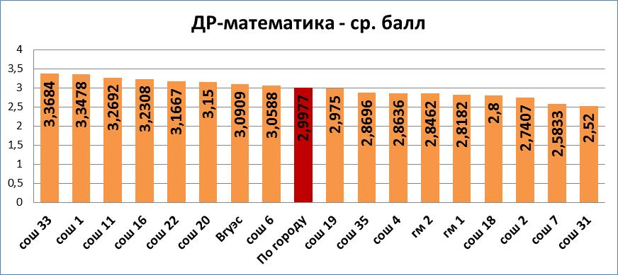

|  |  |  |  |  |  |  |  |  |  |  |  |
| --- | --- | --- | --- | --- | --- | --- | --- | --- | --- | --- | --- |
| **Русский язык** | | | | | | | | | | | |
|  | **Заявлено участников** | **Приняло участие** | **% явки** | **"2"** | **"3"** | **"4"** | **"5"** | **не справились,%** | **ИТОГО** | **ср. балл** | **качество,%** |
| сош 1 | 24 | 17 | 70,83% | 2 | 5 | 9 | 1 | 11,76% | 17 | 3,5294 | 58,82% |
| сош 2 | 27 | 27 | 100,00% | 5 | 9 | 9 | 4 | 18,52% | 27 | 3,4444 | 48,15% |
| сош 3 | 59 | 28 | 47,46% | 0 | 8 | 17 | 3 | 0,00% | 28 | 3,8214 | 71,43% |
| сош 4 | 28 | 23 | 82,14% | 8 | 4 | 7 | 4 | 34,78% | 23 | 3,3043 | 47,83% |
| сош 6 | 22 | 18 | 81,82% | 0 | 8 | 9 | 1 | 0,00% | 18 | 3,6111 | 55,56% |
| сош 7 | 25 | 20 | 80,00% | 0 | 10 | 9 | 1 | 0,00% | 20 | 3,5500 | 50,00% |
| сош 11 | 86 | 76 | 88,37% | 3 | 32 | 30 | 11 | 3,95% | 76 | 3,6447 | 53,95% |
| сош 16 | 22 | 0 (карантин) | - | - | - | - | - | - | - | - | - |
| сош 18 | 34 | 30 | 88,24% | 7 | 13 | 10 | 0 | 23,33% | 30 | 3,1000 | 33,33% |
| сош 19 | 46 | 42 | 91,30% | 1 | 23 | 14 | 4 | 2,38% | 42 | 3,5000 | 42,86% |
| сош 20 | 20 | 19 | 95,00% | 2 | 7 | 5 | 5 | 10,53% | 19 | 3,6842 | 52,63% |
| сош 22 | 25 | 24 | 96,00% | 1 | 12 | 9 | 2 | 4,17% | 24 | 3,5000 | 45,83% |
| сош 31 | 25 | 25 | 100,00% | 3 | 14 | 6 | 2 | 12,00% | 25 | 3,2800 | 32,00% |
| сош 33 | 22 | 19 | 86,36% | 0 | 4 | 10 | 5 | 0,00% | 19 | 4,0526 | 78,95% |
| сош 35 | 27 | 21 | 77,78% | 1 | 10 | 9 | 1 | 4,76% | 21 | 3,4762 | 47,62% |
| гм 1 | 30 | 25 | 83,33% | 2 | 9 | 11 | 3 | 8,00% | 25 | 3,6000 | 56,00% |
| гм 2 | 27 | 26 | 96,30% | 3 | 8 | 7 | 8 | 11,54% | 26 | 3,7692 | 57,69% |
| Вгуэс | 11 | 11 | 100,00% | 1 | 4 | 4 | 2 | 9,09% | 11 | 3,6364 | 54,55% |
| **ИТОГО** | **560** | **451** | **80,54%** | **39** | **180** | **175** | **57** | **8,65%** | **451** | **3,5543** | **51,44%** |

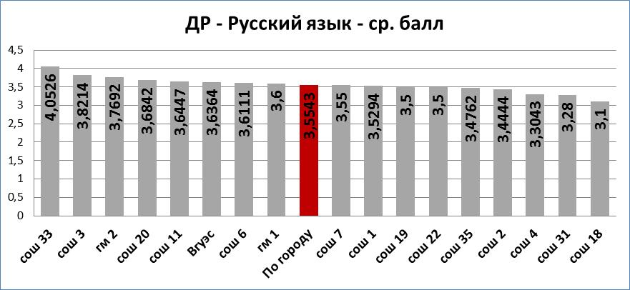

|  |  |  |  |  |  |  |  |  |  |  |  |
| --- | --- | --- | --- | --- | --- | --- | --- | --- | --- | --- | --- |
| **Обществознание** | | | | | | | | | | | |
|  | **Заявлено участников** | **Приняло участие** | **% явки** | **"2"** | **"3"** | **"4"** | **"5"** | **не справились,%** | **ИТОГО** | **ср. балл** | **качество,%** |
| сош 1 | 9 | 9 | 100,00% | 0 | 8 | 1 | 0 | 0,00% | 9 | 3,1111 | 11,11% |
| сош 2 | 13 | 13 | 100,00% | 4 | 8 | 1 | 0 | 30,77% | 13 | 2,7692 | 7,69% |
| сош 3 | 9 | 5 | 55,56% | 0 | 1 | 3 | 1 | 0,00% | 5 | 4,0000 | 80,00% |
| сош 4 | 14 | 13 | 92,86% | 7 | 5 | 1 | 0 | 53,85% | 13 | 2,5385 | 7,69% |
| сош 6 | 8 | 7 | 87,50% | 0 | 6 | 1 | 0 | 0,00% | 7 | 3,1429 | 14,29% |
| сош 7 | 14 | 13 | 92,86% | 4 | 4 | 5 | 0 | 30,77% | 13 | 3,0769 | 38,46% |
| сош 11 | 9 | 9 | 100,00% | 0 | 4 | 4 | 1 | 0,00% | 9 | 3,6667 | 55,56% |
| сош 16 | 10 | 9 | 90,00% | 2 | 3 | 4 | 0 | 22,22% | 9 | 3,2222 | 44,44% |
| сош 18 | 6 | 5 | 83,33% | 0 | 5 | 0 | 0 | 0,00% | 5 | 3,0000 | 0,00% |
| сош 19 | 11 | 0 (карантин) | - | - | - | - | - | - | - | - | - |
| сош 20 | 4 | 4 | 100,00% | 0 | 2 | 2 | 0 | 0,00% | 4 | 3,5000 | 50,00% |
| сош 22 | 12 | 11 | 91,67% | 1 | 8 | 2 | 0 | 9,09% | 11 | 3,0909 | 18,18% |
| сош 31 | 5 | 4 | 80,00% | 1 | 2 | 1 | 0 | 25,00% | 4 | 3,0000 | 25,00% |
| сош 33 | 5 | 5 | 100,00% | 0 | 0 | 5 | 0 | 0,00% | 5 | 4,0000 | 100,00% |
| сош 35 | 7 | 6 | 85,71% | 1 | 5 | 0 | 0 | 16,67% | 6 | 2,8333 | 0,00% |
| гм 1 | 13 | 11 | 84,62% | 0 | 4 | 6 | 1 | 0,00% | 11 | 3,7273 | 63,64% |
| гм 2 | 2 | 8 | 400,00% | 0 | 2 | 5 | 1 | 0,00% | 8 | 3,8750 | 75,00% |
| Вгуэс | 2 | 2 | 100,00% | 0 | 2 | 0 | 0 | 0,00% | 2 | 3,0000 | 0,00% |
| **ИТОГО** | **153** | **134** | **87,58%** | **20** | **69** | **41** | **4** | **14,93%** | **134** | **3,2164** | **33,58%** |

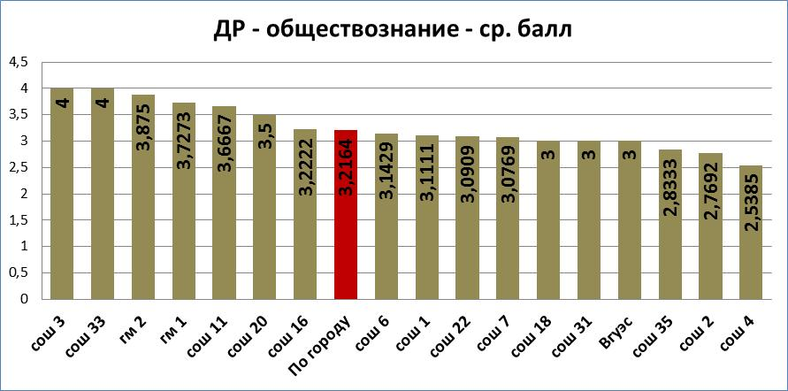

|  |  |  |  |  |  |  |  |  |  |  |  |
| --- | --- | --- | --- | --- | --- | --- | --- | --- | --- | --- | --- |
| **Физика** | | | | | | | | | | | |
|  | **Заявлено участников** | **Приняло участие** | **% явки** | **"2"** | **"3"** | **"4"** | **"5"** | **не справились,%** | **ИТОГО** | **ср. балл** | **качество,%** |
| сош 1 | 1 | 1 | 100,00% | 0 | 0 | 1 | 0 | 0,00% | 1 | 4,0000 | 100,00% |
| сош 2 | 0 | - | - | - | - | - | - | - | - | - | - |
| сош 3 | 15 | 15 | 100,00% | 0 | 5 | 9 | 1 | 0,00% | 15 | 3,7333 | 66,67% |
| сош 4 | 2 | 2 | 100,00% | 1 | 1 | 0 | 0 | 50,00% | 2 | 2,5000 | 0,00% |
| сош 6 | 0 | - | - | - | - | - | - | - | - | - | - |
| сош 7 | 0 | - | - | - | - | - | - | - | - | - | - |
| сош 11 | 27 | 27 | 100,00% | 0 | 12 | 15 | 0 | 0,00% | 27 | 3,5556 | 55,56% |
| сош 16 | 4 | 4 | 100,00% | 0 | 3 | 1 | 0 | 0,00% | 4 | 3,2500 | 25,00% |
| сош 18 | 6 | 6 | 100,00% | 0 | 3 | 3 | 0 | 0,00% | 6 | 3,5000 | 50,00% |
| сош 19 | 7 | 0 (карантин) | - | - | - | - | - | - | - | - | - |
| сош 20 | 3 | 3 | 100,00% | 0 | 1 | 2 | 0 | 0,00% | 3 | 3,6667 | 66,67% |
| сош 22 | 1 | 1 | 100,00% | 0 | 1 | 0 | 0 | 0,00% | 1 | 3,0000 | 0,00% |
| сош 31 | 0 | - | - | - | - | - | - | - | - | - | - |
| сош 33 | 3 | 3 | 100,00% | 0 | 1 | 2 | 0 | 0,00% | 3 | 3,6667 | 66,67% |
| сош 35 | 3 | 3 | 0,00% | 1 | 1 | 0 | 1 | 33,33% | 3 | 3,3333 | 33,33% |
| гм 1 | 5 | 5 | 100,00% | 0 | 2 | 3 | 0 | 0,00% | 5 | 3,6000 | 60,00% |
| гм 2 | 0 | - | - | - | - | - | - | - | - | - | - |
| Вгуэс | 0 | - | - | - | - | - | - | - | - | - | - |
| **ИТОГО** | **77** | **70** | **90,91%** | **2** | **30** | **36** | **2** | **2,86%** | **70** | **3,5429** | **54,29%** |

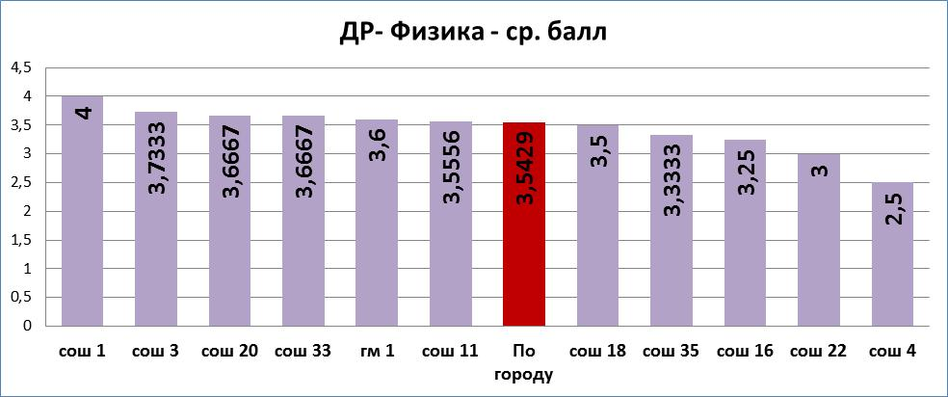

|  |  |  |  |  |  |  |  |  |  |  |  |
| --- | --- | --- | --- | --- | --- | --- | --- | --- | --- | --- | --- |
| **География** | | | | | | | | | | | |
|  | **Заявлено участников** | **Приняло участие** | **% явки** | **"2"** | **"3"** | **"4"** | **"5"** | **не справились,%** | **ИТОГО** | **ср. балл** | **качество,%** |
| сош 1 | 1 | 1 | 100,00% | 0 | 1 | 0 | 0 | 0,00% | 1 | 3,0000 | 0,00% |
| сош 2 | 5 | 5 | 100,00% | 0 | 3 | 2 | 0 | 0,00% | 5 | 3,4000 | 40,00% |
| сош 3 | 13 | 12 | 92,31% | 4 | 5 | 3 | 0 | 33,33% | 12 | 2,9167 | 25,00% |
| сош 4 | 7 | 6 | 85,71% | 5 | 1 | 0 | 0 | 83,33% | 6 | 2,1667 | 0,00% |
| сош 6 | 1 | 1 | 100,00% | 0 | 0 | 0 | 5 | 0,00% | 5 | 5,0000 | 100,00% |
| сош 7 | 2 | 1 | 50,00% | 0 | 0 | 0 | 5 | 0,00% | 5 | 5,0000 | 100,00% |
| сош 11 | 7 | 5 | 71,43% | 0 | 4 | 0 | 1 | 0,00% | 5 | 3,4000 | 20,00% |
| сош 16 | 0 |  | - | - | - | - | - | - | - | - | - |
| сош 18 | 11 | 9 | 81,82% | 2 | 4 | 3 | 0 | 22,22% | 9 | 3,1111 | 33,33% |
| сош 19 | 10 | 0 (карантин) | - | - | - | - | - | - | - | - | - |
| сош 20 | 6 | 4 | 66,67% | 3 | 0 | 1 | 0 | 75,00% | 4 | 2,5000 | 25,00% |
| сош 22 | 5 | 5 | 100,00% | 1 | 2 | 2 | 0 | 20,00% | 5 | 3,2000 | 40,00% |
| сош 31 | 13 | 12 | 92,31% | 4 | 4 | 4 | 0 | 33,33% | 12 | 3,0000 | 33,33% |
| сош 33 | 3 | 1 | 33,33% | 0 | 0 | 1 | 0 | 0,00% | 1 | 4,0000 | 100,00% |
| сош 35 | 3 | 2 | 66,67% | 0 | 1 | 1 | 0 | 0,00% | 2 | 3,5000 | 50,00% |
| гм 1 | 5 | 4 | 80,00% | 1 | 1 | 2 | 0 | 25,00% | 4 | 3,2500 | 50,00% |
| гм 2 | 1 | 1 | 100,00% | 0 | 1 | 0 | 0 | 0,00% | 1 | 3,0000 | 0,00% |
| Вгуэс | 3 | 3 | 100,00% | 0 | 2 | 1 | 0 | 0,00% | 3 | 3,3333 | 33,33% |
| **ИТОГО** | **96** | **72** | **75,00%** | **20** | **29** | **20** | **11** | **25,00%** | **80** | **3,2750** | **38,75%** |

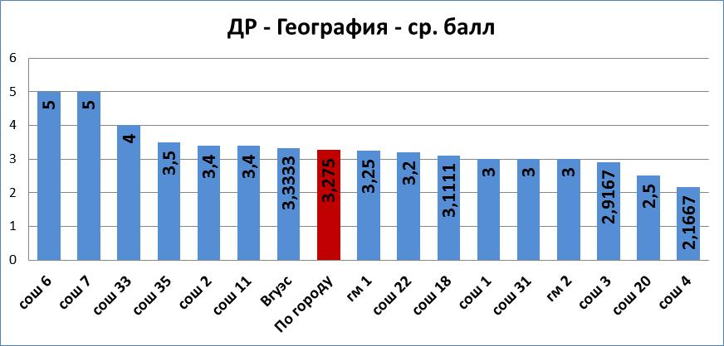

|  |  |  |  |  |  |  |  |  |  |  |  |
| --- | --- | --- | --- | --- | --- | --- | --- | --- | --- | --- | --- |
| **Биология** | | | | | | | | | | | |
|  | **Заявлено участников** | **Приняло участие** | **% явки** | **"2"** | **"3"** | **"4"** | **"5"** | **не справились,%** | **ИТОГО** | **ср. балл** | **качество,%** |
| сош 1 | 2 | 2 | 100,00% | 0 | 0 | 1 | 1 | 0,00% | 2 | 4,5000 | 100,00% |
| сош 2 | 6 | 6 | 100,00% | 0 | 5 | 1 | 0 | 0,00% | 6 | 3,1667 | 16,67% |
| сош 3 | 2 | 3 | 150,00% | 0 | 2 | 1 | 0 | 0,00% | 3 | 3,3333 | 33,33% |
| сош 4 | 1 | 1 | 100,00% | 0 | 0 | 1 | 0 | 0,00% | 1 | 4,0000 | 100,00% |
| сош 6 | 7 | 4 | 57,14% | 0 | 3 | 0 | 1 | 0,00% | 4 | 3,5000 | 25,00% |
| сош 7 | 5 | 4 | 80,00% | 0 | 2 | 2 | 0 | 0,00% | 4 | 3,5000 | 50,00% |
| сош 11 | 6 | 6 | 100,00% | 0 | 3 | 2 | 1 | 0,00% | 6 | 3,6667 | 50,00% |
| сош 16 | 4 | 3 | 75,00% | 0 | 2 | 1 | 0 | 0,00% | 3 | 3,3333 | 33,33% |
| сош 18 | 4 | 4 | 100,00% | 0 | 4 | 0 | 0 | 0,00% | 4 | 3,0000 | 0,00% |
| сош 19 | 6 | 0 (карантин) | - | - | - | - | - | - | - | - | - |
| сош 20 | 1 | 1 | 100,00% | 0 | 1 | 0 | 0 | 0,00% | 1 | 3,0000 | 0,00% |
| сош 22 | 2 | 2 | 100,00% | 0 | 2 | 0 | 0 | 0,00% | 2 | 3,0000 | 0,00% |
| сош 31 | 5 | 5 | 100,00% | 0 | 3 | 2 | 0 | 0,00% | 5 | 3,4000 | 40,00% |
| сош 33 | 2 | 1 | 50,00% | 0 | 0 | 0 | 1 | 0,00% | 1 | 5,0000 | 100,00% |
| сош 35 | 7 | 5 | 71,43% | 0 | 1 | 4 | 0 | 0,00% | 5 | 3,8000 | 80,00% |
| гм 1 | 0 |  | - | - | - | - | - | - | - | - | - |
| гм 2 | 2 | 2 | 100,00% | 0 | 1 | 1 | 0 | 0,00% | 2 | 3,5000 | 50,00% |
| Вгуэс | 1 | 1 | 100,00% | 0 | 1 | 0 | 0 | 0,00% | 1 | 3,0000 | 0,00% |
| **ИТОГО** | **63** | **50** | **79,37%** | **0** | **30** | **16** | **4** | **0,00%** | **50** | **3,4800** | **40,00%** |

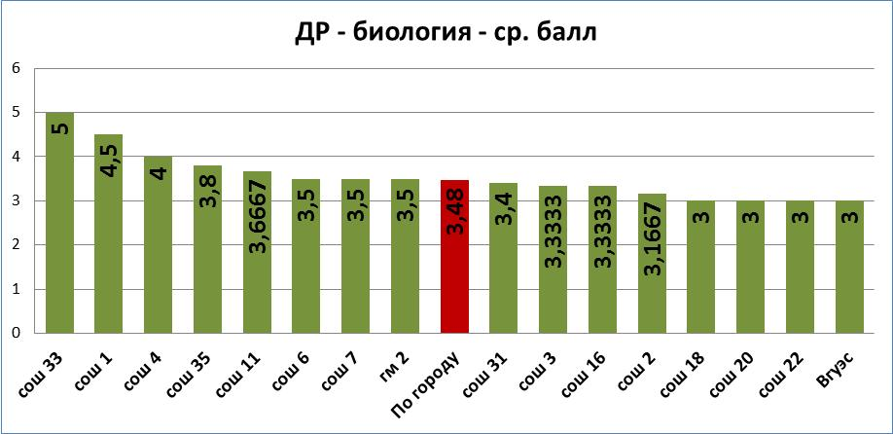

|  |  |  |  |  |  |  |  |  |  |  |  |
| --- | --- | --- | --- | --- | --- | --- | --- | --- | --- | --- | --- |
| **Английский язык** | | | | | | | | | | | |
|  | **Заявлено участников** | **Приняло участие** | **% явки** | **"2"** | **"3"** | **"4"** | **"5"** | **не справились,%** | **ИТОГО** | **ср. балл** | **качество,%** |
| сош 1 | 2 | 2 | 100,00% | 0 | 0 | 2 | 0 | 0,00% | 2 | 4,0000 | 100,00% |
| сош 2 | 1 | 1 | 100,00% | 0 | 0 | 1 | 0 | 0,00% | 1 | 4,0000 | 100,00% |
| сош 3 | 6 | 5 | 83,33% | 0 | 1 | 4 | 0 | 0,00% | 5 | 3,8000 | 80,00% |
| сош 4 | 2 | 2 | 100,00% | 0 | 1 | 1 | 0 | 0,00% | 2 | 3,5000 | 50,00% |
| сош 6 | 1 | 1 | 100,00% | 0 | 1 | 0 | 0 | 0,00% | 1 | 3,0000 | 0,00% |
| сош 7 | 2 | 2 | 100,00% | 0 | 2 | 0 | 0 | 0,00% | 2 | 3,0000 | 0,00% |
| сош 11 | 19 | 18 | 94,74% | 0 | 8 | 10 | 0 | 0,00% | 18 | 3,5556 | 55,56% |
| сош 16 | 1 | 1 | 100,00% | 0 | 0 | 1 | 0 | 0,00% | 1 | 4,0000 | 100,00% |
| сош 18 | 2 | 2 | 100,00% | 0 | 2 | 0 | 0 | 0,00% | 2 | 3,0000 | 0,00% |
| сош 19 | 3 | 0 (карантин) | - | - | - | - | - | - | - | - | - |
| сош 20 | 2 | 2 | 100,00% | 1 | 0 | 1 | 0 | 50,00% | 2 | 3,0000 | 50,00% |
| сош 22 | 1 | 1 | 100,00% | 0 | 0 | 1 | 0 | 0,00% | 1 | 4,0000 | 100,00% |
| сош 31 | 0 |  | - | - | - | - | - | - | - | - | - |
| сош 33 | 2 | 2 | 100,00% | 0 | 2 | 0 | 0 | 0,00% | 2 | 3,0000 | 0,00% |
| сош 35 | 1 | 1 | 100,00% | 0 | 0 | 1 | 0 | 0,00% | 1 | 4,0000 | 100,00% |
| гм 1 | 6 | 5 | 83,33% | 0 | 0 | 5 | 0 | 0,00% | 5 | 4,0000 | 100,00% |
| гм 2 | 3 | 3 | 100,00% | 0 | 0 | 3 | 0 | 0,00% | 3 | 4,0000 | 100,00% |
| Вгуэс | 4 | 4 | 100,00% | 0 | 1 | 3 | 0 | 0,00% | 4 | 3,7500 | 75,00% |
| **ИТОГО** | **58** | **52** | **89,66%** | **1** | **18** | **33** | **0** | **1,92%** | **52** | **3,6154** | **63,46%** |

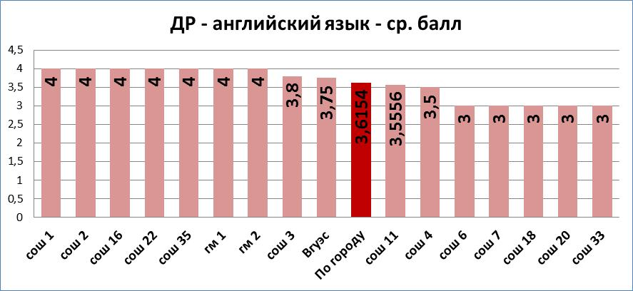

|  |  |  |  |  |  |  |  |  |  |  |  |
| --- | --- | --- | --- | --- | --- | --- | --- | --- | --- | --- | --- |
| **Информатика** | | | | | | | | | | | |
|  | **Заявлено участников** | **Приняло участие** | **% явки** | **"2"** | **"3"** | **"4"** | **"5"** | **не справились,%** | **ИТОГО** | **ср. балл** | **качество,%** |
| сош 1 | 7 | 7 | 100,00% | 1 | 6 | 0 | 0 | 14,29% | 7 | 2,8571 | 0,00% |
| сош 2 | 1 | 1 | 100,00% | 0 | 1 | 0 | 0 | 0,00% | 1 | 3,0000 | 0,00% |
| сош 3 | 5 | 5 | 100,00% | 0 | 5 | 0 | 0 | 0,00% | 5 | 3,0000 | 0,00% |
| сош 4 | 1 | 1 | 100,00% | 0 | 1 | 0 | 0 | 0,00% | 1 | 3,0000 | 0,00% |
| сош 6 | 3 | 3 | 100,00% | 0 | 3 | 0 | 0 | 0,00% | 3 | 3,0000 | 0,00% |
| сош 7 | 1 | 1 | 100,00% | 0 | 1 | 0 | 0 | 0,00% | 1 | 3,0000 | 0,00% |
| сош 11 | 8 | 8 | 100,00% | 0 | 3 | 5 | 0 | 0,00% | 8 | 3,6250 | 62,50% |
| сош 16 | 0 | - | - | - | - | - | - | - | - | - | - |
| сош 18 | 3 | 3 | 100,00% | 0 | 3 | 0 | 0 | 0,00% | 3 | 3,0000 | 0,00% |
| сош 19 | 5 | 0 (карантин) | - | - | - | - | - | - | - | - | - |
| сош 20 | 4 | 3 | 75,00% | 0 | 1 | 0 | 2 | 0,00% | 3 | 4,3333 | 66,67% |
| сош 22 | 1 | 1 | 100,00% | 0 | 1 | 0 | 0 | 0,00% | 1 | 3,0000 | 0,00% |
| сош 31 | 1 | 1 | 100,00% | 0 | 0 | 1 | 0 | 0,00% | 1 | 4,0000 | 100,00% |
| сош 33 | 5 | 4 | 80,00% | 0 | 3 | 1 | 0 | 0,00% | 4 | 3,2500 | 25,00% |
| сош 35 | 6 | 5 | 83,33% | 1 | 2 | 2 | 0 | 20,00% | 5 | 3,2000 | 40,00% |
| гм 1 | 0 | - | - | - | - | - | - | - | - | - | - |
| гм 2 | 5 | 0 (неявка по болезни) | - | - | - | - | - | - | - | - | - |
| Вгуэс | 1 | 1 | 100,00% | 0 | 1 | 0 | 0 | 0,00% | 1 | 3,0000 | 0,00% |
| **ИТОГО** | **57** | **44** | **77,19%** | **2** | **31** | **9** | **2** | **4,55%** | **44** | **3,2500** | **25,00%** |

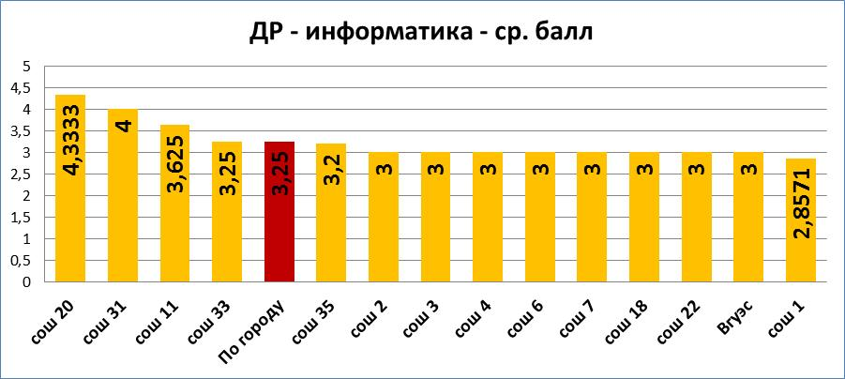

|  |  |  |  |  |  |  |  |  |  |  |  |
| --- | --- | --- | --- | --- | --- | --- | --- | --- | --- | --- | --- |
| **Химия** | | | | | | | | | | | |
|  | **Заявлено участников** | **Приняло участие** | **% явки** | **"2"** | **"3"** | **"4"** | **"5"** | **не справились,%** | **ИТОГО** | **ср. балл** | **качество,%** |
| сош 1 | 2 | 2 | 100,00% | 0 | 0 | 2 | 0 | 0,00% | 2 | 4,0000 | 100,00% |
| сош 2 | 1 | 1 | 100,00% | 0 | 0 | 1 | 0 | 0,00% | 1 | 4,0000 | 100,00% |
| сош 3 | 5 | 5 | 100,00% | 1 | 2 | 2 | 0 | 20,00% | 5 | 3,2000 | 40,00% |
| сош 4 | 1 | 1 | 100,00% | 1 | 0 | 0 | 0 | 100,00% | 1 | 2,0000 | 0,00% |
| сош 6 | 1 | 1 | 100,00% | 1 | 0 | 0 | 0 | 100,00% | 1 | 2,0000 | 0,00% |
| сош 7 | 1 | 1 | 100,00% | 0 | 1 | 0 | 0 | 0,00% | 1 | 3,0000 | 0,00% |
| сош 11 | 9 | 9 | 100,00% | 0 | 4 | 3 | 2 | 0,00% | 9 | 3,7778 | 55,56% |
| сош 16 | 1 | 1 | 100,00% | 0 | 0 | 1 | 0 | 0,00% | 1 | 4,0000 | 100,00% |
| сош 18 | 1 | 1 | 100,00% | 0 | 0 | 1 | 0 | 0,00% | 1 | 4,0000 | 100,00% |
| сош 19 | 3 | 0 (карантин) | - | - | - | - | - | - | - | - | - |
| сош 20 | 0 | - | - | - | - | - | - | - | - |  | - |
| сош 22 | 1 | 1 | 100,00% | 0 | 1 | 0 | 0 | 0,00% | 1 | 3,0000 | 0,00% |
| сош 31 | 1 | 1 | 100,00% | 0 | 0 | 0 | 1 | 0,00% | 1 | 5,0000 | 100,00% |
| сош 33 | 1 | 1 | 100,00% | 0 | 0 | 1 | 0 | 0,00% | 1 | 4,0000 | 100,00% |
| сош 35 | 0 | - | - | - | - | - | - | - | - |  | - |
| гм 1 | 0 | - | - | - | - | - | - | - | - |  | - |
| гм 2 | 3 | 2 | 66,67% | 0 | 2 | 0 | 0 | 0,00% | 2 | 3,0000 | 0,00% |
| Вгуэс | 0 | - | - | - | - | - | - | - | - |  | - |
| **ИТОГО** | **31** | **27** | **87,10%** | **3** | **10** | **11** | **3** | **11,11%** | **27** | **3,5185** | **51,85%** |

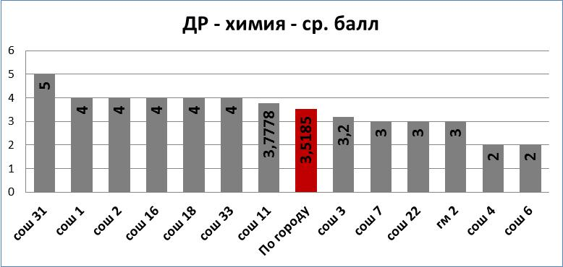

|  |  |  |  |  |  |  |  |  |  |  |  |
| --- | --- | --- | --- | --- | --- | --- | --- | --- | --- | --- | --- |
| **Литература** | | | | | | | | | | | |
|  | **Заявлено участников** | **Приняло участие** | **% явки** | **"2"** | **"3"** | **"4"** | **"5"** | **не справились,%** | **ИТОГО** | **ср. балл** | **качество,%** |
| сош 1 | 0 | - | - | - | - | - | - | - | - | - | - |
| сош 2 | 0 | - | - | - | - | - | - | - | - | - | - |
| сош 3 | 4 | 3 | 75,00% | 1 | 0 | 1 | 1 | 33,33% | 3 | 3,6667 | 66,67% |
| сош 4 | 0 | - | - | - | - | - | - | - | - | - | - |
| сош 6 | 0 | - | - | - | - | - | - | - | - | - | - |
| сош 7 | 0 | - | - | - | - | - | - | - | - | - | - |
| сош 11 | 0 | - | - | - | - | - | - | - | - | - | - |
| сош 16 | 2 | 1 | 50,00% | 1 | 0 | 0 | 0 | 100,00% | 1 | 2,0000 | 0,00% |
| сош 18 | 1 | 1 | 100,00% | 0 | 1 | 0 | 0 | 0,00% | 1 | 3,0000 | 0,00% |
| сош 19 | 1 | 0 (карантин) | - | - | - | - | - | - | - | - | - |
| сош 20 | 0 | - | - | - | - | - | - | - | - | - | - |
| сош 22 | 2 | 2 | 100,00% | 1 | 0 | 0 | 1 | 50,00% | 2 | 3,5000 | 50,00% |
| сош 31 | 0 | - | - | - | - | - | - | - | - | - | - |
| сош 33 | 1 | 1 | 100,00% | 0 | 0 | 0 | 1 | 0,00% | 1 | 5,0000 | 100,00% |
| сош 35 | 0 | - | - | - | - | - | - | - | - | - | - |
| гм 1 | 1 | 1 | 100,00% | 0 | 0 | 0 | 1 | 0,00% | 1 | 5,0000 | 100,00% |
| гм 2 | 1 | 1 | 100,00% | 0 | 0 | 1 | 0 | 0,00% | 1 | 4,0000 | 100,00% |
| Вгуэс | 0 | - | - | - | - | - | - | - | - | - | - |
| **ИТОГО** | **13** | **10** | **76,92%** | **3** | **1** | **2** | **4** | **30,00%** | **10** | **3,7000** | **60,00%** |

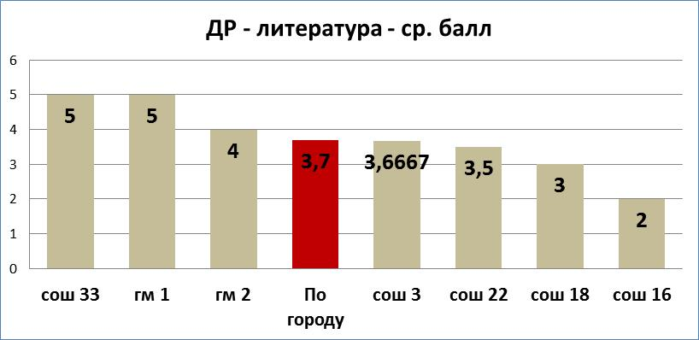

|  |  |  |  |  |  |  |  |  |  |  |  |
| --- | --- | --- | --- | --- | --- | --- | --- | --- | --- | --- | --- |
| **История** | | | | | | | | | | | |
|  | **Заявлено участников** | **Приняло участие** | **% явки** | **"2"** | **"3"** | **"4"** | **"5"** | **не справились,%** | **ИТОГО** | **ср. балл** | **качество,%** |
| сош 1 | 0 | - | - | - | - | - | - | - | - | - | - |
| сош 2 | 0 | - | - | - | - | - | - | - | - | - | - |
| сош 3 | 1 | 1 | 100,00% | 0 | 0 | 1 | 0 | 0,00% | 1 | 4,0000 | 100,00% |
| сош 4 | 0 | - | - | - | - | - | - | - | - | - | - |
| сош 6 | 1 | 0 (неявка по болезни) | - | - | - | - | - | - | - | - | - |
| сош 7 | 0 | - | - | - | - | - | - | - | - | - | - |
| сош 11 | 1 | 1 | 100,00% | 0 | 1 | 0 | 0 | 0,00% | 1 | 3,0000 | 0,00% |
| сош 16 | 0 | - | - | - | - | - | - | - | - | - | - |
| сош 18 | 0 | - | - | - | - | - | - | - | - | - | - |
| сош 19 | 0 | - | - | - | - | - | - | - | - | - | - |
| сош 20 | 0 | - | - | - | - | - | - | - | - | - | - |
| сош 22 | 0 | - | - | - | - | - | - | - | - | - | - |
| сош 31 | 0 | - | - | - | - | - | - | - | - | - | - |
| сош 33 | 0 | - | - | - | - | - | - | - | - | - | - |
| сош 35 | 0 | - | - | - | - | - | - | - | - | - | - |
| гм 1 | 0 | - | - | - | - | - | - | - | - | - | - |
| гм 2 | 0 | - | - | - | - | - | - | - | - | - | - |
| Вгуэс | 0 | - | - | - | - | - | - | - | - | - | - |
| **ИТОГО** | **3** | **2** | **66,67%** | **0** | **1** | **1** | **0** | **0,00%** | **2** | **3,5000** | **50,00%** |

